|  |  |  |  |  |  |
| --- | --- | --- | --- | --- | --- |
| **Module No:** | 5 | **IU No:** | 2 | **Exercise No.** | 2 |

**Name : Ida Bagus Ketut Yoghantara**

|  |  |
| --- | --- |
| **Lab Assessment Statement** | **Assignment 2- Import users into Liferay and give access rights**  **Referring to Assignment-1's Project Scenario,**  The scope of this assignment is to import users into "Online News Portal" and give access to permission according to their role. You have been tasked to create three users in this portal. They are   1. Administrator 2. Site Administrator and 3. Moderator.   **Administrator:** A user who has a regular role with Administrator permission.  **Site Administrator:** A user who has a site role with Site Administrator permission within a specific website.  **Moderator:** A moderator who has a Moderator role that user has permission to manage all the contents within a specific website.  To implement the task, complete the following steps:   1. Log in as a Portal Administrator,   Create a new role for "Moderator" and define permission to manage all the contents of "Online News Portal".  (Other administrator roles are already defined in Liferay Portal.)   1. Create three users and assign the relevant role to all users. 2. Check different access rights between Administrator, site administrator, and Moderator.   **Provide a brief description and screenshots for each step.** |
| **Technical Environment** | - |
| **Guidelines** | - |
| **Duration** | 60 mins |

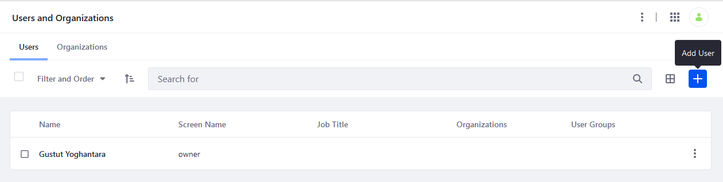

1. **Administrator  
   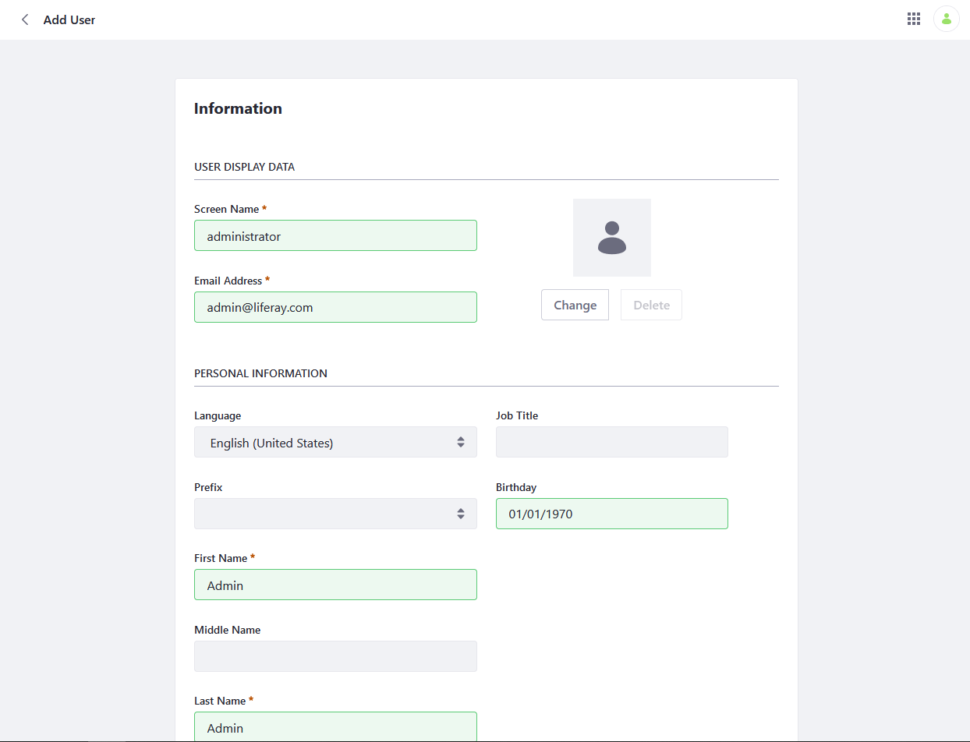  
     
   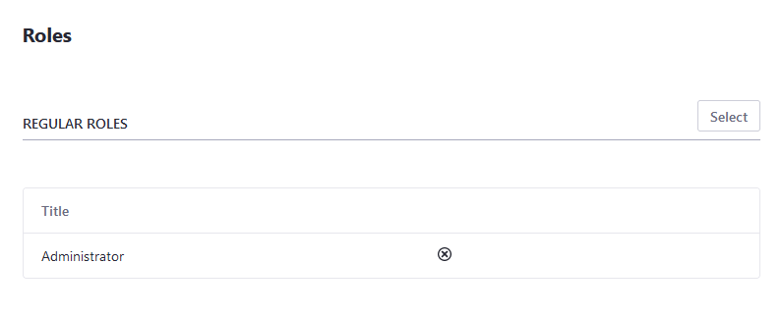  
   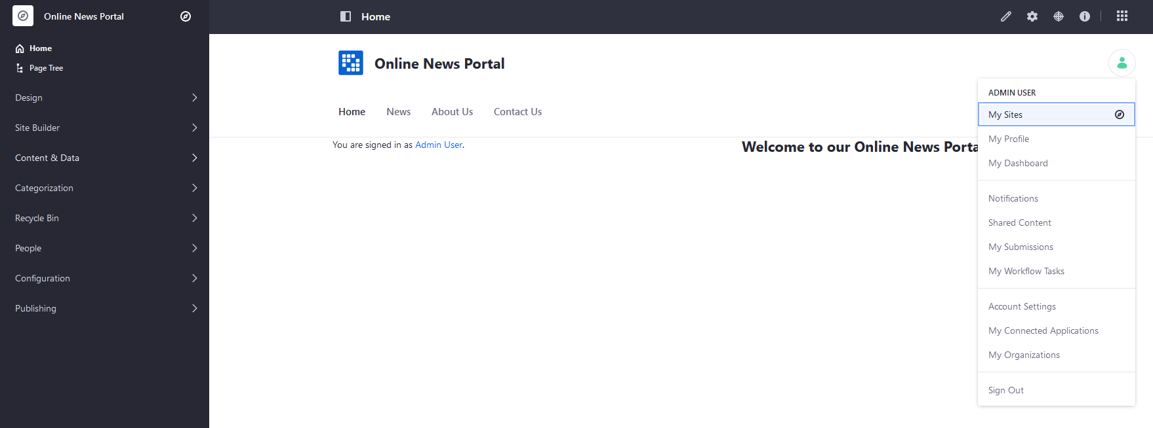**
2. **Site Administrator  
   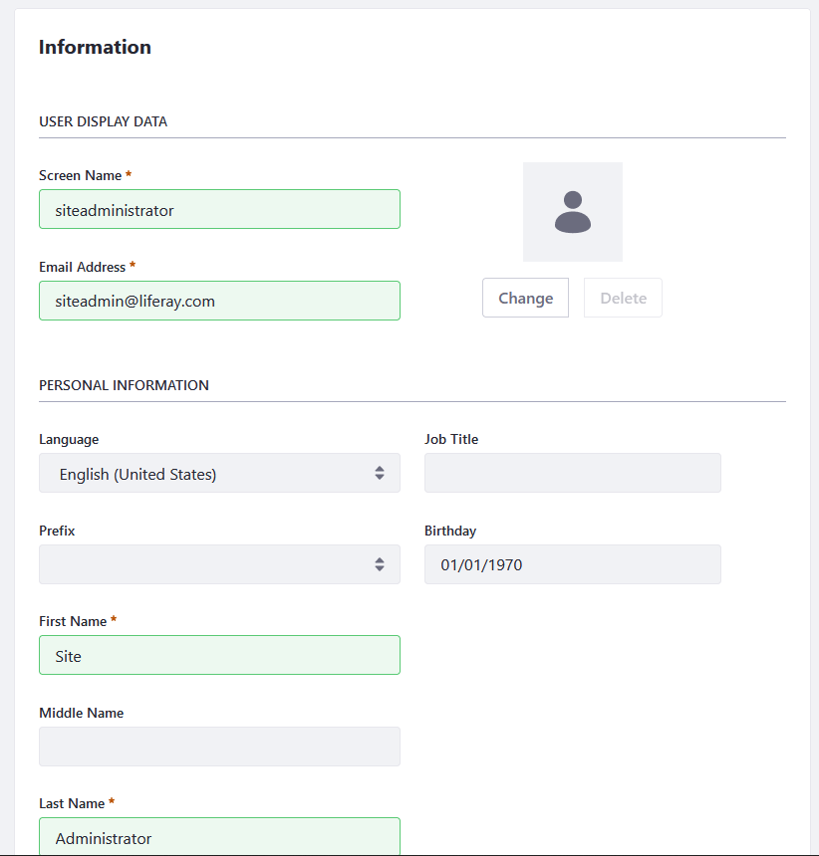  
   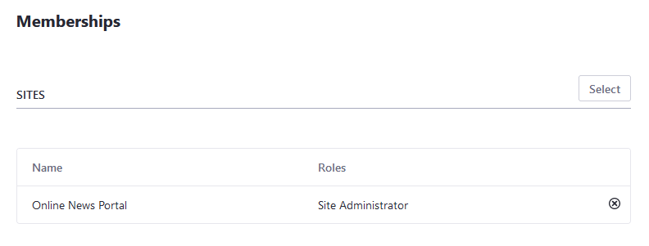  
   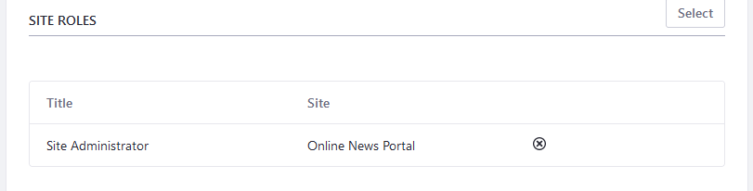  
     
   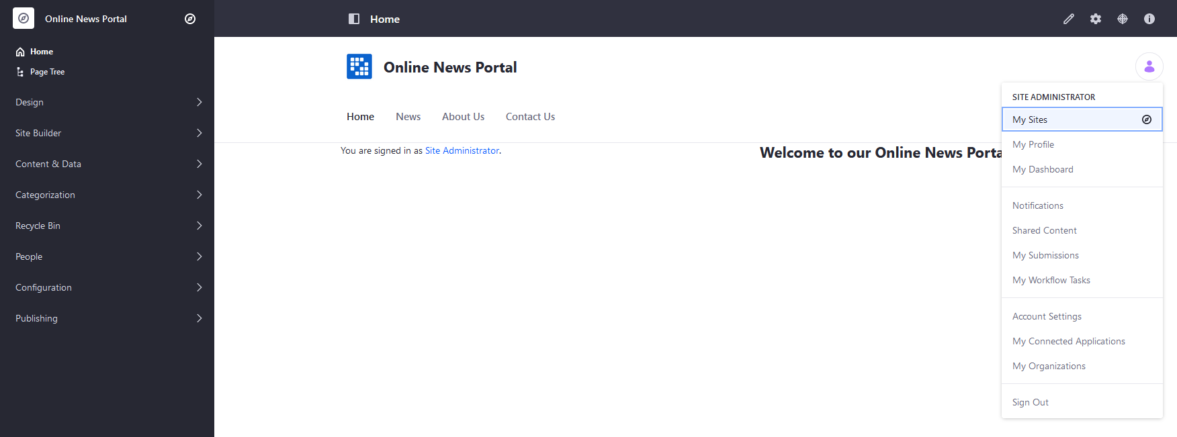**
3. **Moderator  
   